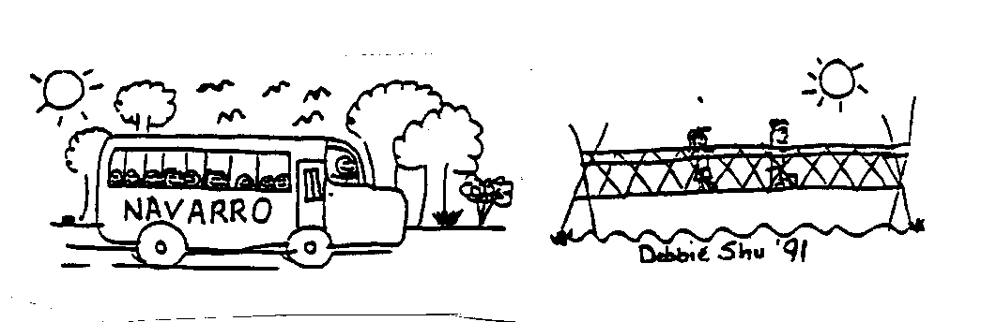
Suggested List of Materials
Sixth Grade Camp Navarro

Saturday, April 29, 2017 to Friday, May 5, 2017

Please keep a checklist of your child’s belongings and label his/her clothes.
- Underwear
- T-shirts or light tops
- Sweatshirts (2)
- Socks (lots—8 pair minimum)
- Pants (3)
- PJ’s or sweat clothes for sleeping
- Jacket
- Poncho or rain jacket
- Shorts
- Swim suit
- (2 pair) Shoes, hiking boots or other sturdy comfortable footwear
- Shower sandals or Teva-style sandals with back straps (excellent for hiking in water)
- Camp mattress pad, inflatable mattress or thin rubber pad
- Extra warm (flannel is great) blanket—very important if sending a light weight sleeping bag
- Sleeping bag and pillow
- One bar of hand soap (in plastic baggie)
- Two bath towels
- Toothbrush and toothpaste
- Washcloth
- Lip balm
- Sun block or lotion
- Stocking cap (for cold evenings) and sun/baseball style hat
- Camera
- Flashlight with extra batteries
- Day-pack style backpack
- Book to read
- Water bottle
- Non-aerosol bug repellent
PLEASE DO NOT PACK ANY OF THE FOLLOWING:
Radios or portable stereos/Ipods TVs pocketknives matches/lighters Candy or gum Cell phones
Gameboys or other hand-held, battery-operated games

