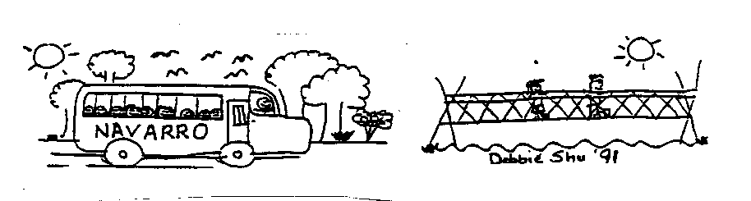

Camp Notes 2017

Camp dates: Saturday, April 29th to Friday, May 5th, 2017

On Saturday, April 29, your child will be able to participate in the forty-second annual outdoor education camp conducted by the Old Adobe Union School District. The six-day camp is held at Camp Navarro in Mendocino County.
This newsletter is intended to give you important information concerning dates, times, activities and policies. Please keep it for future reference.
Considerable planning, fundraising and discussion go into our preparations for camp, and this year is no exception. Your child is one of over 300 students who have sold gift-wrap, washed cars, sold chocolates, and participated in other fundraisers, in order to make camp possible. The outdoor education program wouldn’t be possible without the support of the families of our district. We thank you and hope to make camp a very positive experience for your child.
Craig Conte Camp Co-Director, Principal
Old Adobe Union School District
(707) 765-4326

Michele Gochberg Camp Co-Director, Principal
Sonoma Mountain Elementary Charter School
(707) 765-4305

Linda Brown, Camp Co-Director
Old Adobe Elementary School
(707) 765-4301

Camp website: campnavarro.weebly.com

VERY IMPORTANT DATES AND TIMES

• Student baggage at La Tercera Elementary:
Thursday, April 27th 3:00 - 6:00 pm

• Load buses for Camp Navarro at La Tercera:
Saturday, April 29th - Loading 2:00 pm, buses depart 2:30 pm

• Buses return campers from Camp Navarro to the Lucchesi Center:
Friday, May 5th between 1:00 – 2:00 pm

Baggage
Please be sure that all baggage is clearly marked and properly labeled. Experience has taught us that plastic garbage bags DO NOT WORK as suitcases. Cloth bags, duffel bags, packs or suitcases are best. Be sure that your child’s bags arrive at La Tercera the FRIDAY BEFORE CAMP, THURSDAY, APRIL 27 BETWEEN 3:00 AND 6:00 P.M. BAGGAGE WILL NOT GO ON THE STUDENT BUS ON SATURDAY, APRIL 29TH.

Health and Safety
• Your child’s camp health form should have been collected by your child’s teacher and will be collected for review by the district’s nurse. It is imperative that allergies or any other medical conditions were clearly marked on this form.

• If your child is bringing medication to camp, please send it in a properly labeled bottle, in a brown “lunch” bag, which you have labeled with your child’s name and the name of the medication. Give the bag with the medication to the camp nurse on Saturday, April 29 before your child boards the bus at La Tercera. Please be sure to fill out and sign the Medication Form before you deliver the medication.

• The camp nurse will keep all medications with her in the nurse’s office at camp. If your child must take medication on a regular basis, that medication must be taken in the nurse’s office. Instruct your child to go to the nurse’s office to receive any medication. The camp nurse is not responsible for finding each child to give medication. If your child uses an inhaler, please make sure that they bring adequate medication. Two full inhalers would be sufficient.

• Be certain to pick up your child’s medication inside the Lucchesi Center when you pick up your child after camp. If you have any questions or concerns regarding medications or any other health issues please contact Michele Gochberg at (707) 765-4305 or email mgochberg@oldadobe.org.

• The camp will have a nurse or nurse assistant on site 24 hours a day. If the nurse has questions about medications or your child’s condition, the nurse will contact you by phone. Make certain you have provided, on your health form, phone numbers where you may be reached during the week we are at camp.

Supervision
In addition to the sixth grade teachers of the Old Adobe Union District, high school and college counselors and adult volunteers will also be present at camp.
During the day, study groups of approximately 30 campers are paired with at least one teacher and 6 to 8 counselors. During the evening and night hours a team of teachers will patrol the student sleeping areas.

Discipline
Sixth Grade Camp Navarro is an Old Adobe Union School District campus and all district behavior expectations and guidelines are enforced. Consequences for not adhering to the behavior guidelines may include loss of daily activity events and community service. Behavior that would result in a school suspension such as fighting, sexual harassment, or defiance of school authority will result in a student being sent home from camp. Parents are responsible for transportation.
Counselors
Counselors selected for this year’s camp will arrive Saturday prior to the arrival of the campers. Our veteran counselors are primarily from Case Grande, Saint Vincent and Petaluma High School; however, many of the returning counselors are college students or graduates who have made arrangements from busy schedules to help with camp. All “veteran” counselors have worked effectively with sixth grade students in the past and have been invited to return in 2017. All new counselors have gone through an interview and training process prior to their selection as camp counselors.

Counselors receive training in listening skills and basic communication skills. Additionally they review general safety tips and safety precautions. Counselors and staff will share this information with campers.

The Camp Directors have selected lead counselors and staff members who will prepare the counselors for their scheduled assignments during the week of camp. They will be outlining expectations regarding conduct and behavior for all counselors and campers alike.

Leave it at Home
By now you should have received a list of items to bring to camp, but let us remind you to keep the following at home: radios, TV, electronic games, music players or any electronic noise makers. We also remind you to keep candy and gum at home. Both attract four-legged raiders!

Communications
We encourage family members to place notes to your child in the camp luggage. We will not be accepting mail via the postal service, FedEx, UPS, etc.!

Routine phone calls for general information or questions may be directed to the Old Adobe Union District Office at 765-4321. In an EMERGENCY you may call the camp at (707) 895-3181. This is the number of the camp ranger’s home, so PLEASE use it in an emergency situation only.

Visitors
Parents and other guests are always welcome to visit Camp Navarro during the week. Please be sure to follow these guidelines:
1. Visitors must check-in at the Camp Office/Nurses Station upon arrival in Navarro.
2. Visitors are not allowed in students sleeping areas.
3. Overnight guests must stay in assigned cabins. There is a $25 fee per person for each night in camp.
4. Visitors on day excursions will be assigned groups based on space availability or other criteria by the Camp Directors.
Thanks for your cooperation. These guidelines are for the safety and security of the campers.

